Nishit Shah

Student number: 130 176 217

Email Id: ngshah3@myseneca.ca

Section: SYD366 NGG

Group : 10

**Inventory Test – Answered**

**Case Study**

Ally runs *Vitatec,* a small nutritional company that supplies nutrition and vitamins to gyms. Ally employs a small team, including some office, sales, and warehouse staff. A few times a year, Ally attends trade shows and visits manufacturers to learn about new products. Ally uses an outside delivery service to deliver orders to their gyms. A few times a year, Ally attends trade shows and visits manufacturers to learn about new flooring supply products and equipment.

Your team has started looking at Ally’s inventory records and found that Ally records measurements for each of the products that she stocks, for proper placement in her warehouse. Ally orders products from various suppliers through their online ordering portals, and must record her purchases so that she knows what she’s purchased and what’s about arrive at his warehouse.

Your team leader has written the following scenarios to capture Ally’s requirements. Receipt

|  |  |  |  |
| --- | --- | --- | --- |
| **Use Case Name** | **Create Product Information** | | |
| **Triggering Event** | A new product of interest to the business | | |
| **Brief Description** | Allows the Owner to record a new product. | | |
| **Actors** | Owner | | |
| **Related Use Cases** |  | | |
| **Preconditions** | Owner has opened the Main Menu. | | |
| **Post Conditions** | Product is saved to the database and now can be purchased or used in a service. | | |
| **Flow of activities** | **Actor** | | **System** |
|  |  | Requests to add a new product | Displays a list of products currently recorded in the system and prompts to add a new product. |
|  |  | Enters the product name, description, weight, color, ingredient and type of the new product. | Verifies that all of the data is entered. Displays the newly created product and requests to save. |
|  |  | Request to save | Saves the product and returns to the main menu |
| **Exception Conditions** | * Owner chooses to cancel adding the product | | |

|  |  |  |  |
| --- | --- | --- | --- |
| **Use Case Name** | **Create Purchase** | | |
| **Triggering Event** | Purchase of a product. | | |
| **Brief Description** | Allows the Owner to record a new purchase. | | |
| **Actors** | Owner | | |
| **Related Use Cases** |  | | |
| **Preconditions** | Owner has opened the Main Menu. | | |
| **Post Conditions** | Purchase is saved to the database and now can be queried. | | |
| **Flow of activities** | **Actor** | | **System** |
|  | 1. | Requests to add a new purchase | Displays a list of suppliers and prompts for selection. |
|  | 2. | Selects a supplier. | Verifies that a supplier was selected. Displays a calendar and prompts for purchase date , type and expected delivery date. |
|  | 3. | Selects purchase date, expected delivery date and type | Verifies that purchase date and delivery date were selected.  Creates a unique identifier for the purchase. Prompts to enter product details. |
|  | **Loop** | Chooses new detail | Displays a list of products and prompts for selection. Prompts for price, quantity ordered and quantity received |
|  | 4. | Selects a product and enters price and quantity. | Product must be selected.  Price and quantity must be entered  Data is valid  Dollar value of the detail is calculated and added to the total dollar value of the purchase  Dollar value of purchase and purchase detail are displayed  Prompts to add another product |
|  | **End** | When all products selected | Displays purchase including totals, date and list of products.  Verifies that at least one product has been selected.  Prompts to save purchase |
|  | 5. | Chooses to save | Saves the purchase and returns to the main menu |
| **Exception Conditions** | * Owner chooses to cancel adding the purchase | | |

Question 1 (worth 20 marks)

Complete a class diagram to support what your team has learned so far about *Vitatec.*

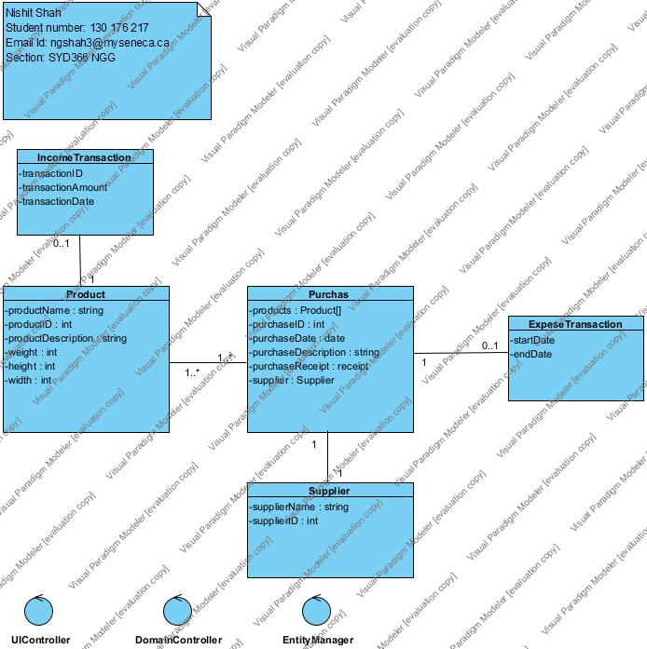

Question 2 (worth 25 marks)

Complete sequence diagrams to support the above scenarios.

(1):-

CASE: **Create Product Information**

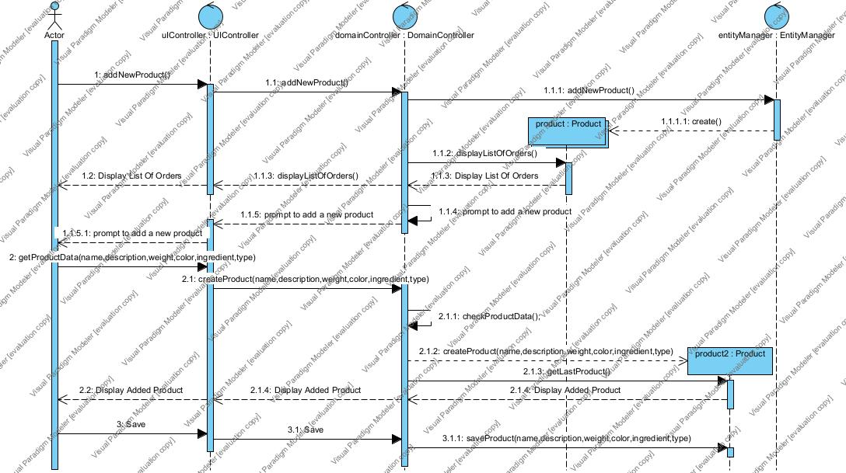

(2):-

CASE: **Purchase of a product**

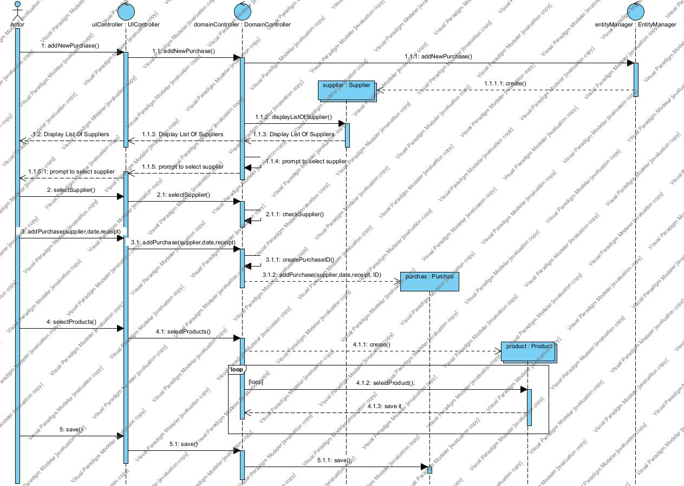

Question 3 (worth 2 marks)

Ally would like the system to suggest how much he should expect delivery to cost. To do that, she needs to know how much the purchase will weigh. How would you change your model to support this request?

* We already have classes to track the purchases per month. We can simply add an class named MonthlyPrediction in which we can add some calculations and get the final amount of next month’s expected expenses. We can do the same for other needs as well.

Question 4 (worth 15 marks)

Please prototype what visual paradigm would output for your Domain Controller.

CASE: **Create Product Information**

**-Main menu  
-The list of all products in data base  
-Input options for adding new product (input options : Name, Description, Weight, Color, Ingredients, Type)   
-Save Option  
-Main menu**

Question 5 (worth 3 marks)

Ally finds a sale on vinyl flooring and would like to buy six months’ worth of product. How would she use your model to figure out how many to buy?

* At current state of model, It is hard to figure out how many product to buy. But we can update our model here to help her. We can add some basic calculations according to his past 6 months of sales. We already have all the info needed in Transaction classes. It will be simple to calculate the number by the data on hand.
* After we update our model, Ally will be able to use our model to determine how many to buy.